|  |  |
| --- | --- |
| EXERCICES | POINTS |
| Exercise 1 | 10 |
| Exercise 2 | 10 |
| Exercise 3 | 30 |
| Exercise 4 | 50 |
| **TOTAL** | **100** |

**Exercise 1: Boolean expression**

Demonstrate these equalities using the 7 simplification rules you have learnt.

1. (A or B or C) and (!A or B or C) = B or C

(A or B or C) and (!A or B or C)

= (A or (B or C)) and (!A or (B or C))

=((B or C) or A) and ((B or C) or !A)

= (B or C) and (A or !A)

=(B or C) and true

=B or C

1. (A and B) or (!A or !B) = True

(A and B) or (!A or !B) = ((!A or !B) or A) and ((!A or !B) or B)

=((A or !A) or (A or !B)) and ((B or !A) or (B or !B))

=(true or (A or !B)) and (true or (!A or B))

=true and true

= true

**Exercise 2: Truth table**

1. **A and (A or B)**

|  |  |  |
| --- | --- | --- |
| **A** | **B** | **A and (A or B)** |
| True | True | True |
| True | False | True |
| False | True | False |
| False | False | False |

A and (A or B) = (A and A) or (A and B) = A or (A and B) = (A or A) and (A or B)

=true and (A or B)

=(true and A) or (true and B) =A or B

1. **(A and B) or !C or [C and (!A or !B)]**

|  |  |  |  |
| --- | --- | --- | --- |
| **A** | **B** | **C** | **(A and B) or !C or [C and (!A or !B)]** |
| True | True | True | True |
| True | True | False | True |
| True | False | True | True |
| True | False | False | True |
| False | True | True | True |
| False | True | False | True |
| False | False | True | True |
| False | False | False | True |

(A and B) or !C or [C and (!A or !B)]

= (A and B) or !C or [(C and !A) or (C and !B)]

=(A and B) or [(!C or (C and !A)) or (!C or (C and !B))

=(A and B) or [True and (!C or !A) or (true and (!C or !B))

=(A and B) or [(!C or !A) or (!C or !B)]

=(A and B) or (!C or (!A or !B))

=((A and B)or !C) or ((A and B) or (!A and !B))

=((A and B)or !C) or true

= True

**Exercise 3: Ranges**

1. **Simplify** the expressions
2. a < 3 or a > 3

a >3

1. a >5 or a < 6

a < 6

1. a > 2 and a > 12

a > 2

1. a >= 8 or a > 8

a > 8

1. a >=0 and a <= 0

a =0

1. Draw the shape corresponding to the boolean expression
2. (x = y)

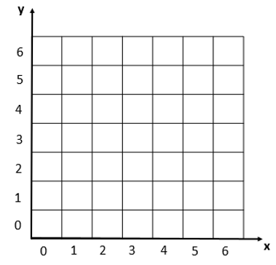

1. (x>2) and not((x>3 and x<4) and (y>2 and y<6))



1. Write the boolean condition for this grid

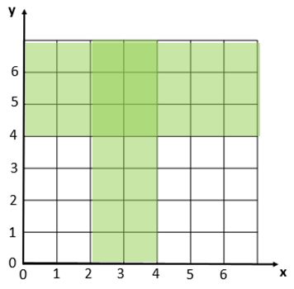

Expression:

(x>2 and x<4) or y>4

**Exercise 4: Flowcharts**

1. Draw the tree of conditions

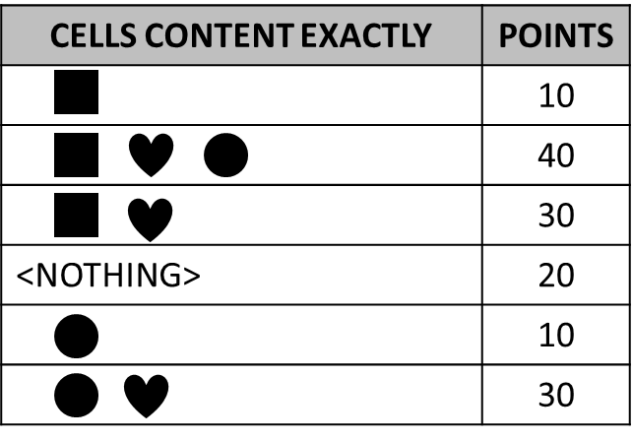

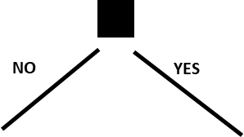

YES

NO

0

0

0

YES

NO

YES

30

10

NO

YES

YES

20

NO

30

NO

40

YES

10

NO

NO

1. Say what I do thanks to the flowchart below?
   1. It is Monday, it’s hot and I have homework. What I do?

Work

* 1. It’s Sunday, it’s cold, it’s not raining, I don’t like bicycle and I’m not tired. What I do?

Watch a movie

* 1. It’s Friday, it’s cold and raining, I’m tired but I don’t have homework. What I do?

Sleep

* 1. When do I ride my bike? **Give a boolean expression**

It’s hot, not weekend, don’t have homework, I like bicycle.

OR It’s not hot, It’s weekend, It’s not raining, I like bicycle.

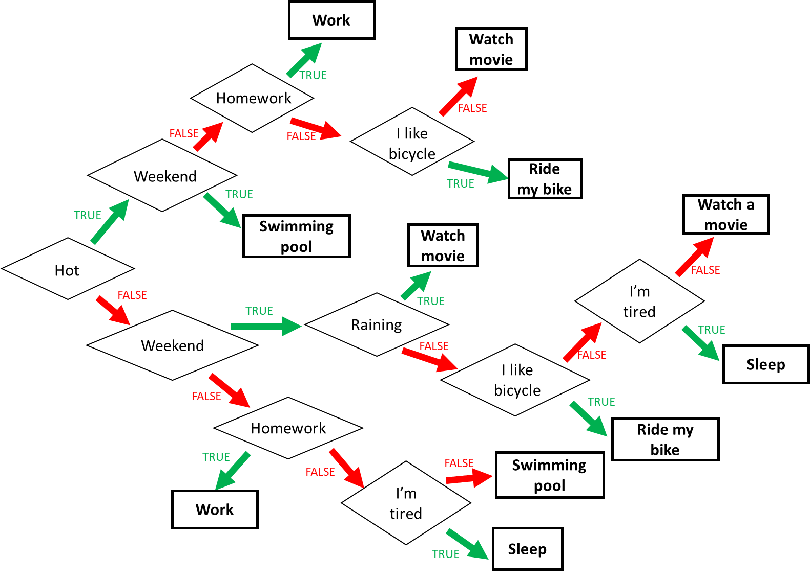

1. Find the boolean expression of **RED** of this flowchart

RED : CAB or CA!BDE or CA!B!D!E or C!AB or !CAD or !C!AB!E or !C!A!BE

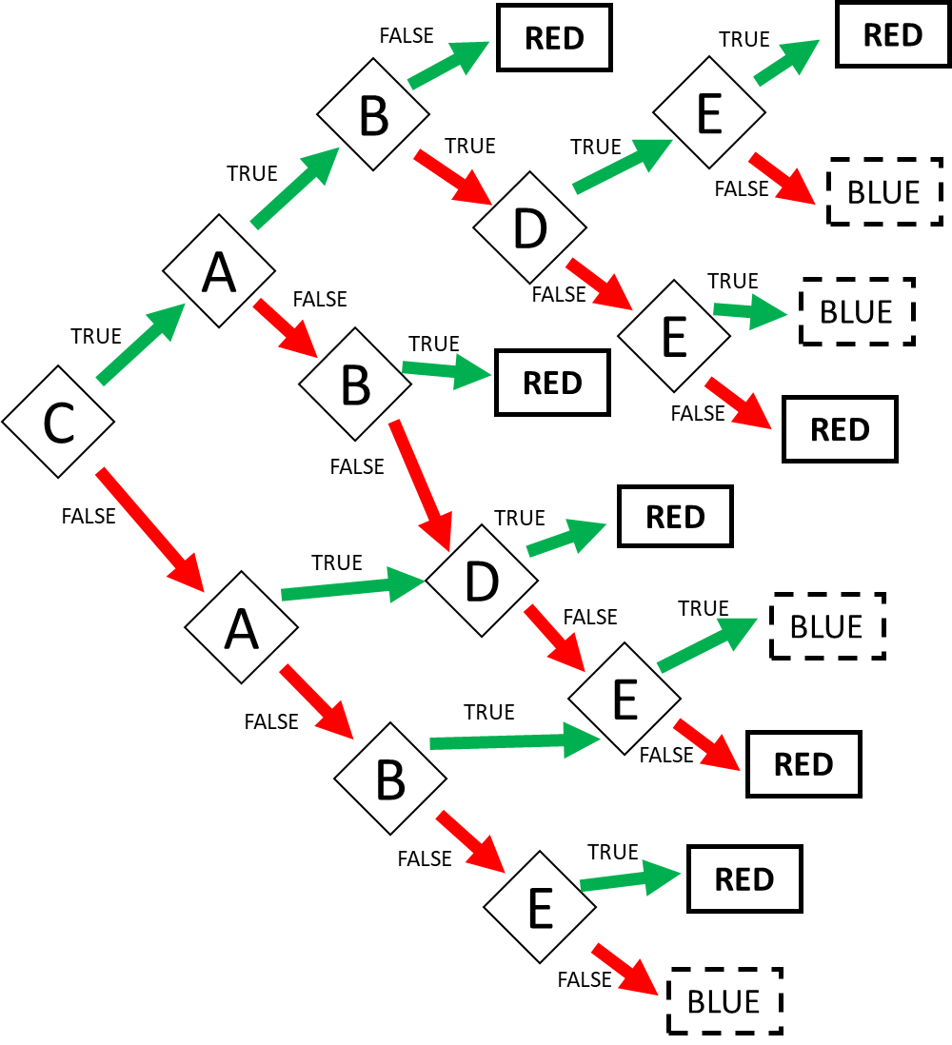

Expression: RED = CAB or CA!BDE

or CA!B!D!E or C!AB………………………………………………………………..